

Foundations of Programming

Name : Sahil Gujarathi
PRN : 1262252760
DIV : 1

Foundations of Programming

Assignment No.: 19
PROBLEM STATEMENT: Create Structure EMPLOYEE for storing details (Name, Designation, gender, Date of Joining and Salary). Define function members to compute a) total number of employees in an organization b) count of male and female employee c) Employee with salary more than 10,000 d) Employee with designation “Asst Manager”

OBJECTIVE:

- To understand the use of structures in C programming.
- To store and manage employee records using structures.
- To perform operations such as counting and filtering employee data

THEORY:
In the C programming language, a structure is a user-defined data type that groups related variables of different data types under a single name. Structures are widely used for representing records such as employee information. In this program, a structure named EMPLOYEE is created to store employee details such as name, designation, gender, date of joining, and salary. By using loops and conditional statements, the program can calculate the total number of employees, count male and female employees, find employees whose salary is greater than 10,000, and display employees having the designation 'Asst Manager'.
PLATFORM: Linux
INPUT:
#include <stdio.h>
#include <string.h>

struct EMPLOYEE
{
char name[50];
char designation[50];
char gender[10];
int day, month, year; // Date of Joining
float salary;
};

/* Function to count male and female employees */
void countGender(struct EMPLOYEE e[], int n)
{
int male = 0, female = 0;

for(int i = 0; i < n; i++)
{
if(strcmp(e[i].gender, "Male") == 0 || strcmp(e[i].gender, "male") == 0)
male++;
else
female++;
}

printf("\nMale Employees: %d", male);
printf("\nFemale Employees: %d\n", female);
}

/* Function to display employees with salary > 10000 */
void salaryAbove10k(struct EMPLOYEE e[], int n)
{
printf("\nEmployees with salary more than 10000:\n");

for(int i = 0; i < n; i++)
{
if(e[i].salary > 10000)
{
printf("%s\n", e[i].name);
}
}
}

/* Function to display Assistant Managers */
void assistantManagers(struct EMPLOYEE e[], int n)
{
printf("\nEmployees with designation Asst Manager:\n");

for(int i = 0; i < n; i++)
{
if(strcmp(e[i].designation, "Asst Manager") == 0)
{
printf("%s\n", e[i].name);
}
}
}

int main()
{
int n;

printf("Enter number of employees: ");
scanf("%d", &n);

struct EMPLOYEE e[n];

for(int i = 0; i < n; i++)
{
printf("\nEnter details of employee %d\n", i+1);

printf("Name: ");
scanf("%s", e[i].name);

printf("Designation: ");
scanf("%s", e[i].designation);

printf("Gender (Male/Female): ");
scanf("%s", e[i].gender);

printf("Date of Joining (dd mm yyyy): ");
scanf("%d %d %d", &e[i].day, &e[i].month, &e[i].year);

printf("Salary: ");
scanf("%f", &e[i].salary);
}

/* a) Total employees */
printf("\nTotal number of employees: %d\n", n);

/* b) Male and Female count */
countGender(e, n);

/* c) Salary > 10000 */
salaryAbove10k(e, n);

/* d) Asst Manager */
assistantManagers(e, n);

return 0;
}

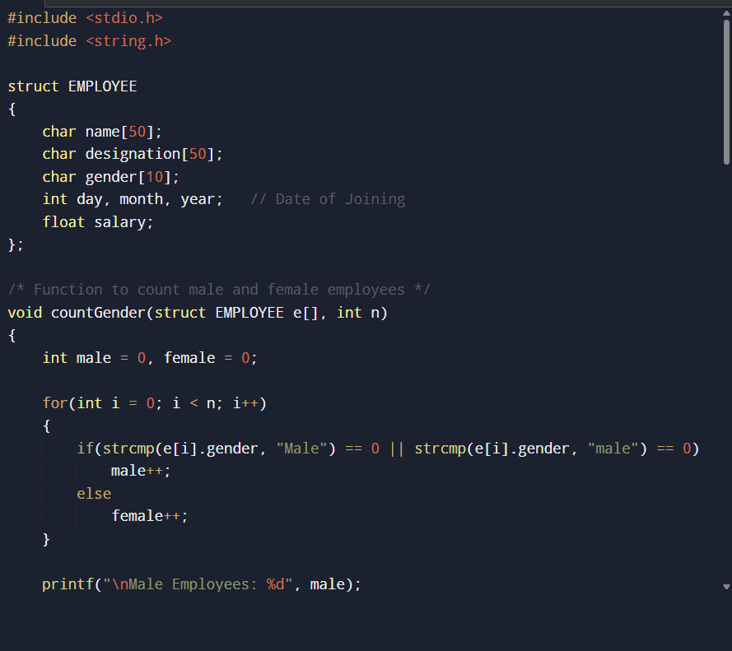
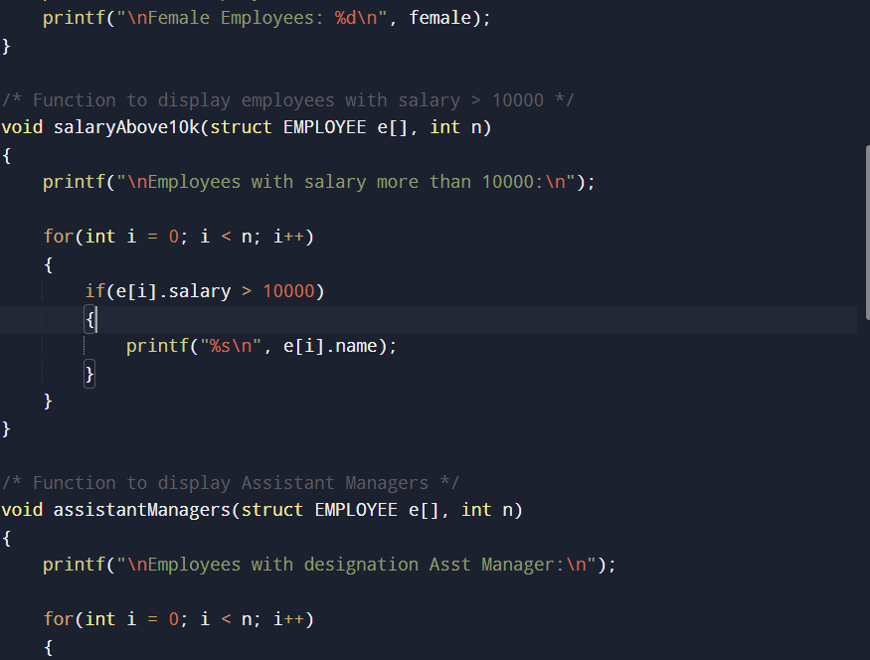
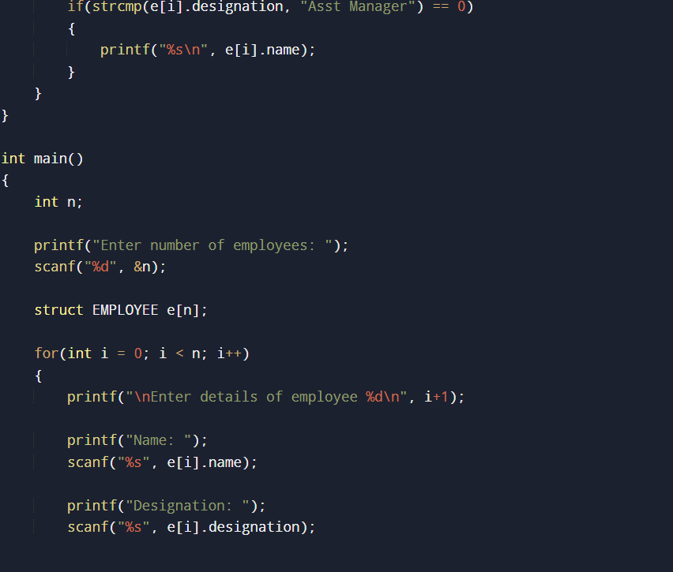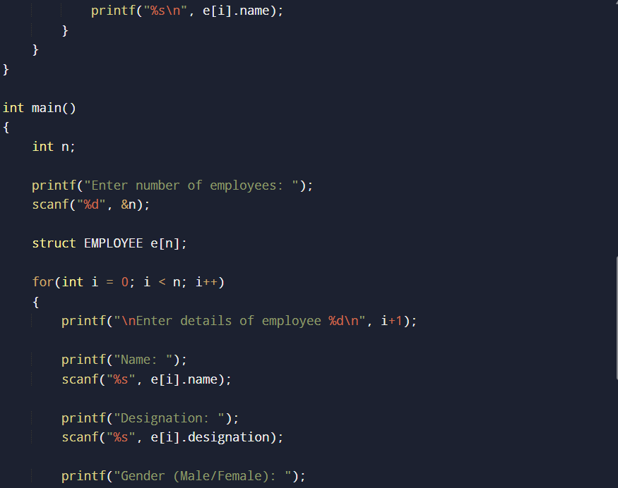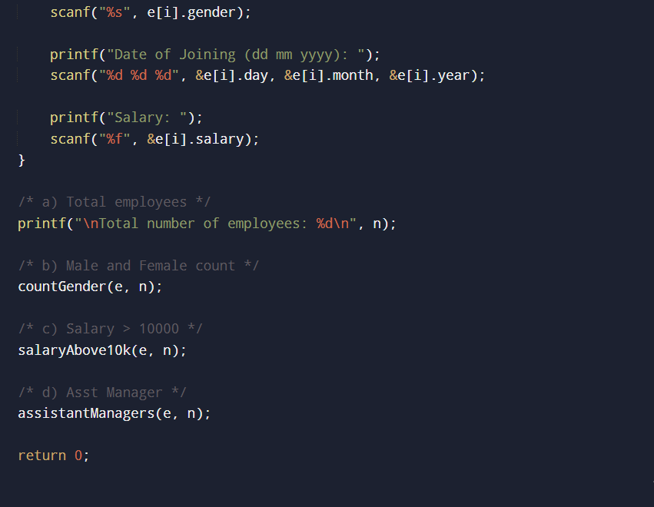

OUTPUT:
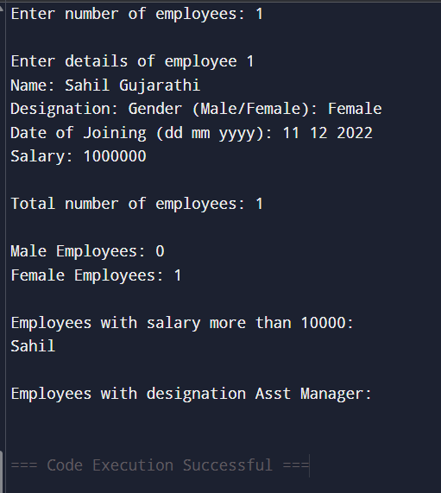

SAMPLE INPUT:
Enter number of employees: 2
Employee 1: Ravi, AsstManager, Male, 12-05-2022, 15000
Employee 2: Anita, Clerk, Female, 10-01-2023, 8000

SAMPLE OUTPUT:
Total number of employees = 2
Male employees = 1
Female employees = 1
Employees with salary more than 10000: Ravi
Employees with designation AsstManager: Ravi

CONCLUSION: Thus, the C program successfully demonstrates the use of structures to store employee details and perform various operations such as counting employees, identifying employees with salary greater than 10,000, and displaying employees with the designation 'Asst Manager'.

FAQs:
- How does a structure in the C programming language help in organizing multiple related data items such as employee details?
- Why are structures preferred over simple variables or arrays when managing records like employee information?
- How can conditional statements and functions be used with structures to filter employees based on salary or designation?

